Why the need for Third Party Risks assessment?
As companies embrace new technologies to drive their digital transformation initiatives, cyber risks remain a top priority concern for business leaders. As a consequence of wide-reaching and successful cyberattacks, Third Party Management (TPM) has become companies’ focal point. To maintain a sound security posture, organizations need to assess the vendor ecosystem to ensure that risks of cybersecurity, privacy breach, ethics and compliance are mitigated and environmental, social, and governance goals are achieved.

Our consultants, with years of expertise, are renowned for conducting and evaluating third-party security assessments on behalf of our esteemed clients. We pride ourselves on our methodology in evaluating third parties’ security controls, leveraging our deep understanding and unparalleled skill set to ensure that third parties’ systems and processes are robust, compliant, and secure.

Our Approach
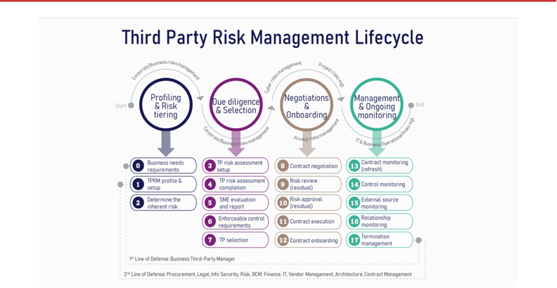

How does it work?

- Third-party risk management is a process of holding enterprises accountable to good risk management practices.
- Improve the risk management capabilities of your third parties to improve the security of the Internet.
- Identify and centrally manage all vendors in a single platform. Gaining visibility into your third-party ecosystem is the first and most important step to understanding your risk exposure.
- Extend that visibility to third-party technology usage. When a breach that impacts a specific technology occurs, you can map impacted vendors easily and target risk assessments accordingly.
- Automate risk assessments, including questionnaire selection, response workflow and reporting.
- Score responses based on specific risk thresholds. This will enable your team to target the most critical risks first.
- Offer proactive reports on incident response progress and mitigations to satisfy the needs of regulators, board members, and other stakeholders.

The benefits
Reduce Compliance and | Risk Management and Compliance/Audit teams want to achieve compliance and
regulatory pressures | address the risks of working with IT vendors – a different type of reporting.
 | Ensure that third parties protect the privacy of any personal information collected
Enforce Privacy requirements | and/or processed by ensuring that appropriate controls are in place to mitigate risk
 | to avoid regulatory, financial, and reputational exposures.
Manage multiple parties | Unified internal teams with a single set of workflows, third-party risk profiles,
 | assessments, and reporting.
Clear-cut onboarding workflows, | The Procurement team owns the third-party vendor/ supplier relationship but not the
assessment processes, and risks | program and is driven by speeding and simplifying new vendor onboarding.
Improve visibility into Third Party | Analytics and reports to prioritized third-party risks and to measure the effectiveness
risk | of the program.
Inculcate Third Party code of | Work within a framework of ethical and professional standards, regulations, policies,
conduct | and values.
Align audit reports to | Instil trust by demonstrating due diligence and a strong security posture to clients
 | and be proactive with auditors in measuring compliance against data protection
standards
 | regulations.
Produce insightful reports to | Reports on risks mitigation, threat management, compliance and supplier’s
 | ecosystem coverage are easily available, including the respective Key Performance
Business and Board members
 | Indicators (KPIs) and Key Risk Indicators (KRIs).

About us

We specialize in assisting C-level executives in navigating the complexity of security governance, risk management and regulatory compliance requirements while bridging the gap between management objectives and technical teams. Our team of consultants and engineers are focused problem solvers with deep technical knowledge and broad industry experience with coverage ranging from government and tier one financial services to telco and mining sectors.

